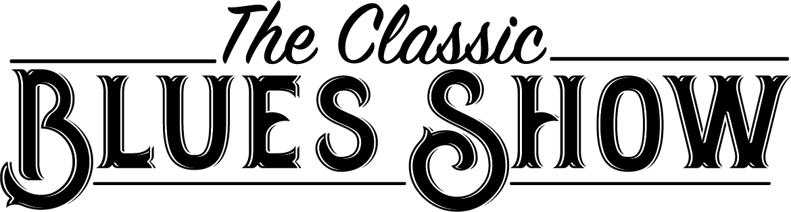

Spend an evening in the company of this fine six-piece band to celebrate the British Blues explosion of the 1960s. From BB King to John Mayall, from Muddy Waters to Peter Green: The Classic Blues Show recreates the authentic sound of British Blues musicians and the artists who inspired them.

This band of experienced musicians has its roots all firmly anchored in the blues. This is the blues of not just the Delta, Chicago, and elsewhere in the USA but also the blues of Ealing, Dartford and wherever else formed the British Blues Boom of the 60's and beyond.

Driving guitar riffs and assured vocals matched by a swinging horn section, make this a show to remember. Enjoy the music and stories from those lucky enough to be there - and feel the blues come alive.

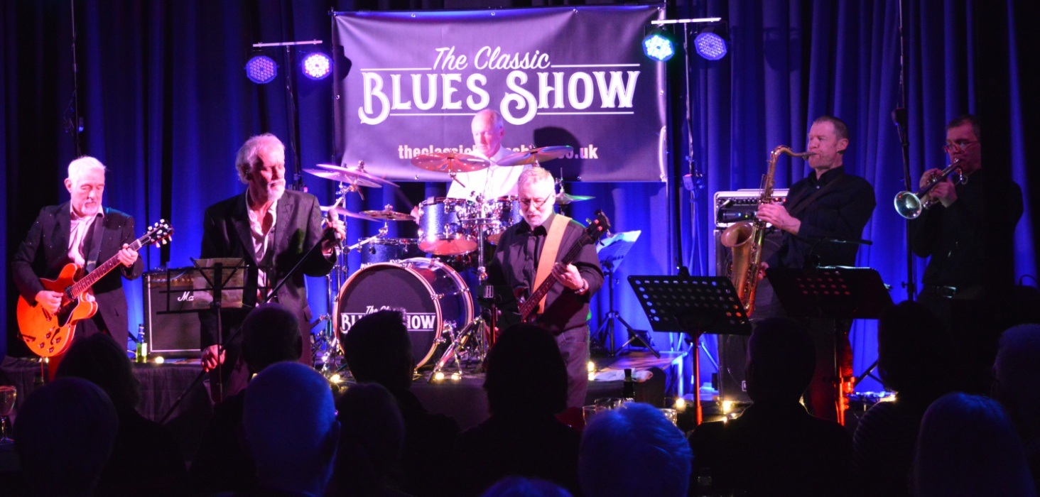
“A true journey through the history of blues by EXCELLENT musicians. If you’re a blues music fan then this is the band for you. Check them out, go see them live, a MUST SEE BAND.” LIVE N LOUD
“A highly enjoyable and entertaining evening for classic blues fans! Professionally put together and played by experienced musicians... The first event was a sell-out and we’re delighted that the Classic Blues Show is returning” Ludlow Brewery
“What a great evening. What a great band. What’s not to like? They’re already booked in again for next year.” Montgomery Town Hall

Contact us: info@theclassicbluesshow.co.uk or 07807018110
or use our contact form https://theclassicbluesshow.co.uk/wordpress/contact/
https://theclassicbluesshow.co.uk https://www.facebook.com/theclassicbluesshow/

